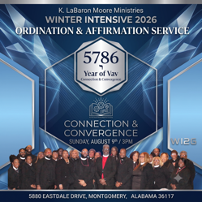
KLMM/KAF 5-FOLD ORDINATION/AFFIRMATION
DRESS AND APPEARANCE

The following dress code will be strictly enforced.

*ROLE/OFFICE | BASE | COLLAR | ECCLESIASTICAL CHAIN/CROSS | NOTES
ALL: Women
Conservative black suites/skirt or pants permitted. Conservative earrings, rings, and nail polish. Black, closed-toe shoes preferred. Appropriate leg-wear – no fishnets or overlay fashionable nylons.
A single, conservative lapel pen may be worn on all suites.

Men
Studs or conservative earrings permitted for men. Black shoes – no two-toned shoes and colors. A single, conservative lapel pen may be worn on all suites. Black socks – no designer/excessively printed designs.

Evangelist | All black | Tab | Braided White | See above
Prophet | All black | Tab | Braided White | Wear Blue Chain/Cross permitted by choice.
Pastor | All black | Full Roman | Braided Red/White | See above
Teacher | All black | Tab | Braided White | See above
Minister | All black | Tab | Braided White | See above
Overseer | All black | Full Roman | Braided Red/White | See above
Elder | All black | Tab | Braided White | See above
*Affirmed/Ordained candidates that have an established, personal ministry my receive OVERSEER ordination and would wear full Roman collar as Pastor/Overseer.

- Wear of (Black) Robe or Vestment is permitted.

- Kingdom Agenda covenant connection is permitted but not required
- Mercy Robes – Atlanta, GA

